Asia-China-Coin-Spade-Three Hole-H 3.484 R 1

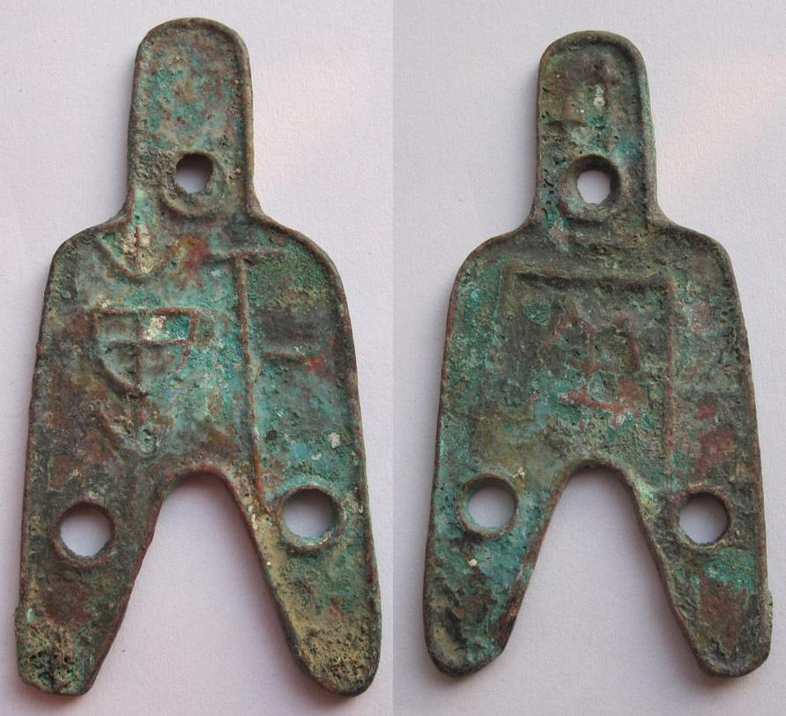

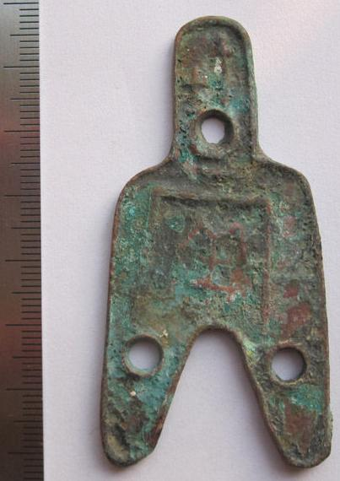 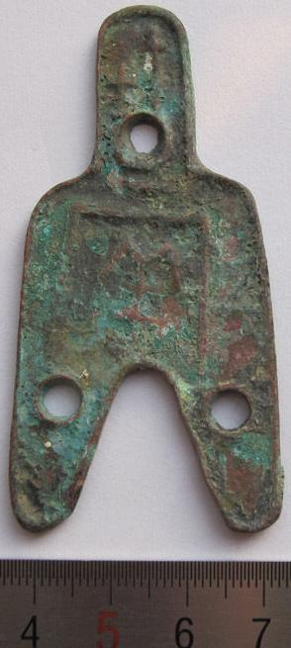 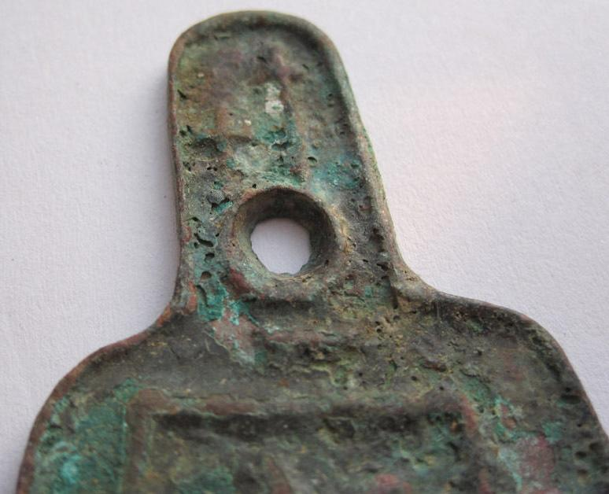 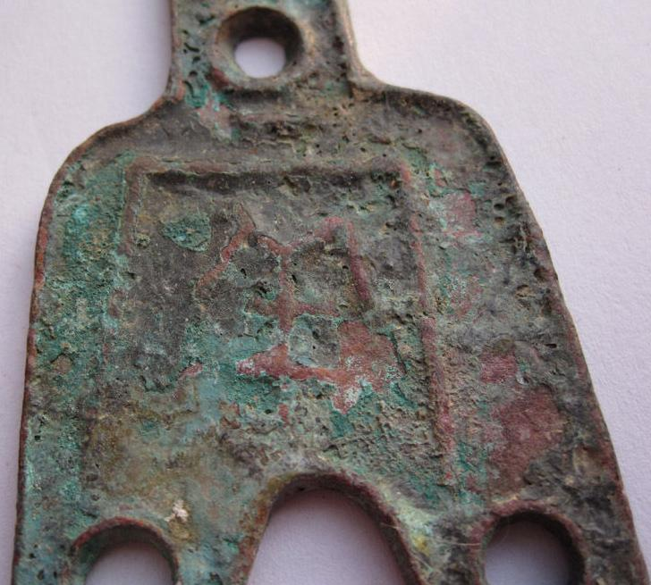

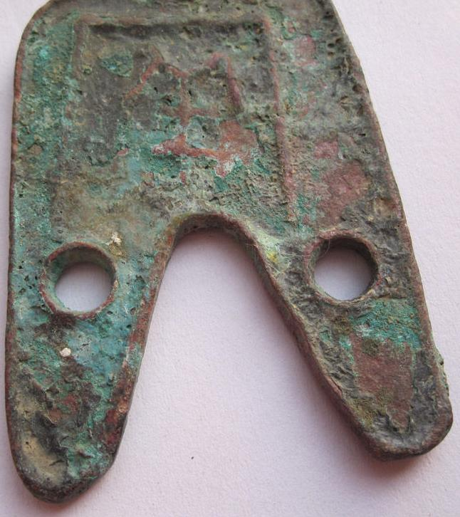 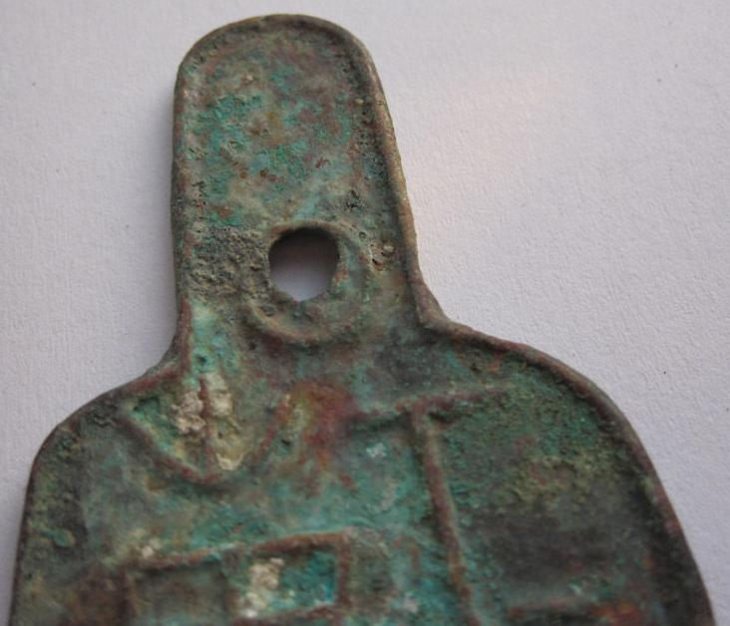 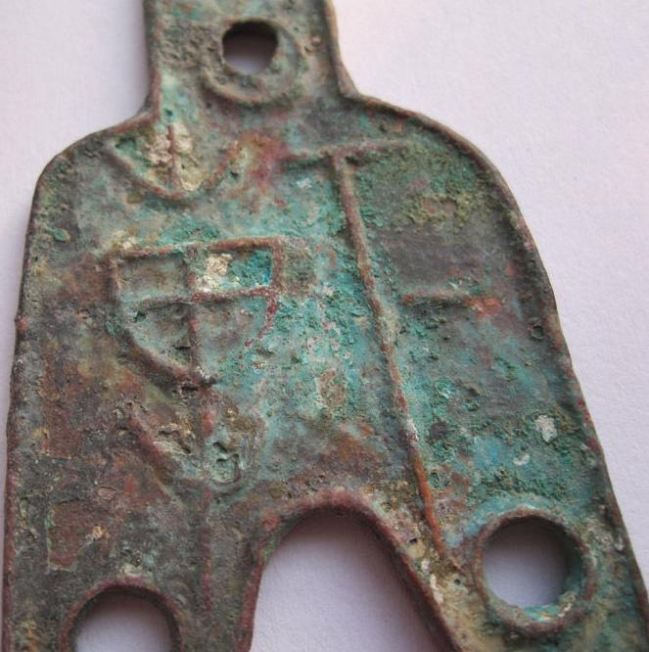 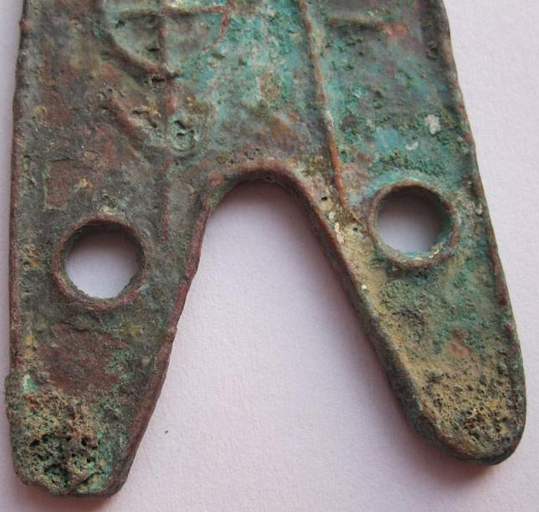

# Warring states Three-hole original coin 090221

### Seller information

|  |  |
| --- | --- |
|  |  |

[linzhoulin](http://myworld.ebay.com/linzhoulin?_trksid=p2047675.l2559) ([3117](http://feedback.ebay.com/ws/eBayISAPI.dll?ViewFeedback&userid=linzhoulin&iid=380800682675&ssPageName=VIP:feedback&ftab=FeedbackAsSeller&rt=nc&_trksid=p2047675.l2560) )

100% Positive feedback

[Follow this seller](http://www.ebay.com/itm/Warring-states-Three-hole-original-coin-090221-/380800682675?nma=true&si=5L4Tlo08dyY9pQflhUEb6fWvMTI%253D&orig_cvip=true&rt=nc&_trksid=p2047675.l2557)

[See other items](http://www.ebay.com/sch/linzhoulin/m.html?item=380800682675&nma=true&rt=nc&si=5L4Tlo08dyY9pQflhUEb6fWvMTI%253D&orig_cvip=true&_trksid=p2047675.l2562)

Visit store:

[linzhoulin](http://stores.ebay.com/linzhoulin?_trksid=p2047675.l2563)

Top of Form

## Item Information

Item condition:

--not specified

Ended:

Dec 25, 2013 10:04:24 PST

Winning bid:

US $19.88

[ [1 bid](http://offer.ebay.com/ws/eBayISAPI.dll?ViewBids&_trksid=p2047675.l2565&rt=nc&item=380800682675) ]

|  |  |  |  |
| --- | --- | --- | --- |
|  | Join **eBay Bucks** and earn **%** back on this item. [See conditionsfor eBay Bucks - opens in a new window or tab](http://pages.ebay.com/rewards/terms.html?ssPageName=STRK:VI:LNLK:TCS) | |  |
|  | | New customers get $10 back on 1st purchase Subject to credit approval.[See terms](https://apply.billmelater.com/apply?guid=1SJ8TEIO&assetId=NBRVI1213) | |

Shipping:

FREE Economy Shipping from outside US | [See details](http://www.ebay.com/itm/Warring-states-Three-hole-original-coin-090221-/380800682675?nma=true&si=5L4Tlo08dyY9pQflhUEb6fWvMTI%253D&orig_cvip=true&rt=nc&_trksid=p2047675.l2557" \l "shpCntId)

See details about international shipping here.

Item location:

SH, China

Ships to:

Worldwide [See exclusions](http://www.ebay.com/itm/Warring-states-Three-hole-original-coin-090221-/380800682675?nma=true&si=5L4Tlo08dyY9pQflhUEb6fWvMTI%253D&orig_cvip=true&rt=nc&_trksid=p2047675.l2557" \l "shpCntId)

Bottom of Form